Hadoop(HDFS) Setup (Ubuntu)
Installation and Setup of Java:
- In redhat java is already installed
  - If not, installed it with below command
#yum install java (For Redhat)
#sudo apt-get install java (For Ubuntu)
Installing JDK (Version above 1.6)
  - Download JDK from oracle website below is the link
http://www.oracle.com/technetwork/java/javase/downloads/jdk8-downloads-2133151.html
- For redhat download jdk-8u181-linux-x64.tar.gz .
- Now set the PATH for jdk.
  - Create directory /usr/java and put extracted jdk in it.
  - Now open /root/.bashrc to edit path (add below lines to it)
#vim /root/.bashrc
export JAVA_HOME=/usr/java/jdk1.8.0_171-amd64
export PATH=$JAVA_HOME/bin:$PATH
Now check the version of java
#java -version
Output should be like below
java version "1.8.0_171"
Java(TM) SE Runtime Environment (build 1.8.0_171-b11)
Java HotSpot(TM) 64-Bit Server VM (build 25.171-b11, mixed mode)
Upto here Java and jdk path is set.

Installation of Hadoop:
- Download Hadoop file from below path:
https://archive.apache.org/dist/hadoop/core/hadoop-2.6.0/
- Extract Hadoop Packager
#tar -xvzf hadoop-2.6.2.tar.gz (Respective Downloaded file)
#mv hadoop-2.6.4 /hadoop2
- Set Hadoop Path (in /root/.bashrc)
#export HADOOP_HOME=/hadoop2
#export PATH=$HADOOP_HOME/bin:$HADOOP_HOME/sbin:$PATH
- Verify
#hadoop version
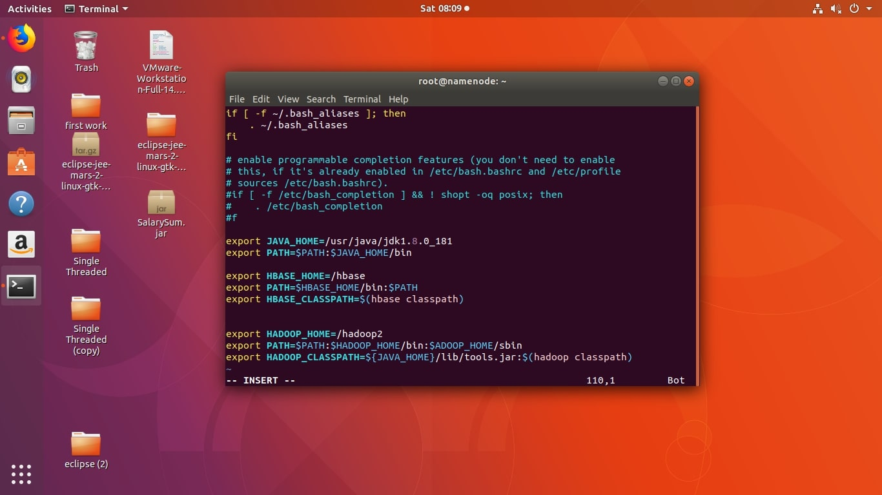
Upto here hadoop is setup...
Hadoop Hdfs (Configuration)
To Setting up hadoop we have to make changes in hadoop configuration file. Following above installation directory and path, we found hadoop configuration files in /hadoop2/etc/hadoop.
Setting up Namenode(Apply these chances in namenode)
Open directory #cd /hadoop2/etc/hadoop
Find hdfs-site.xml in above directory and make chances in it’s configuration block.
1. To provide the directory of hadoop
<Configuration>
<property>
<name>dfs.namenode.name.dir</name>
<value>file:/namenode</value>
</property>
<property>
<name>dfs.block.size</name>
<value>134217728</value> //Size is in bytes
</property>
<property>
<name>dfs.replication</name>
<value>3</value>
</property> </Configuration>
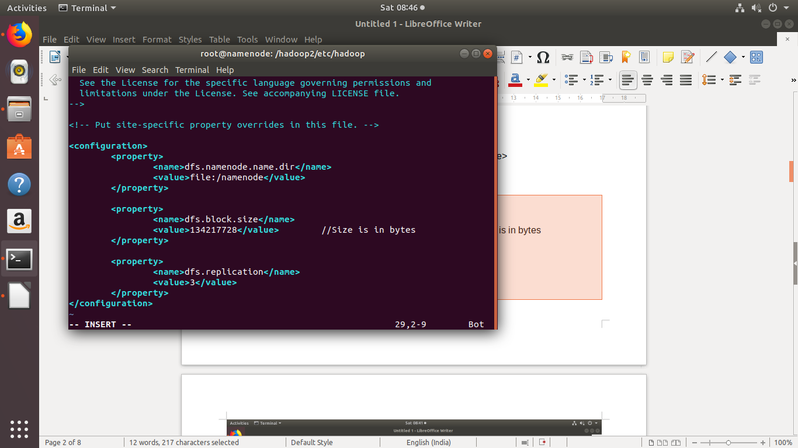
Find core-site.xml and makes following chances in it.
Add configuration file for namenode ip_address
<configuration>
<property>
<name>fs.default.name</name>
<value>hdfs://ip of namenode:10001</value>
</property>
</configuration>
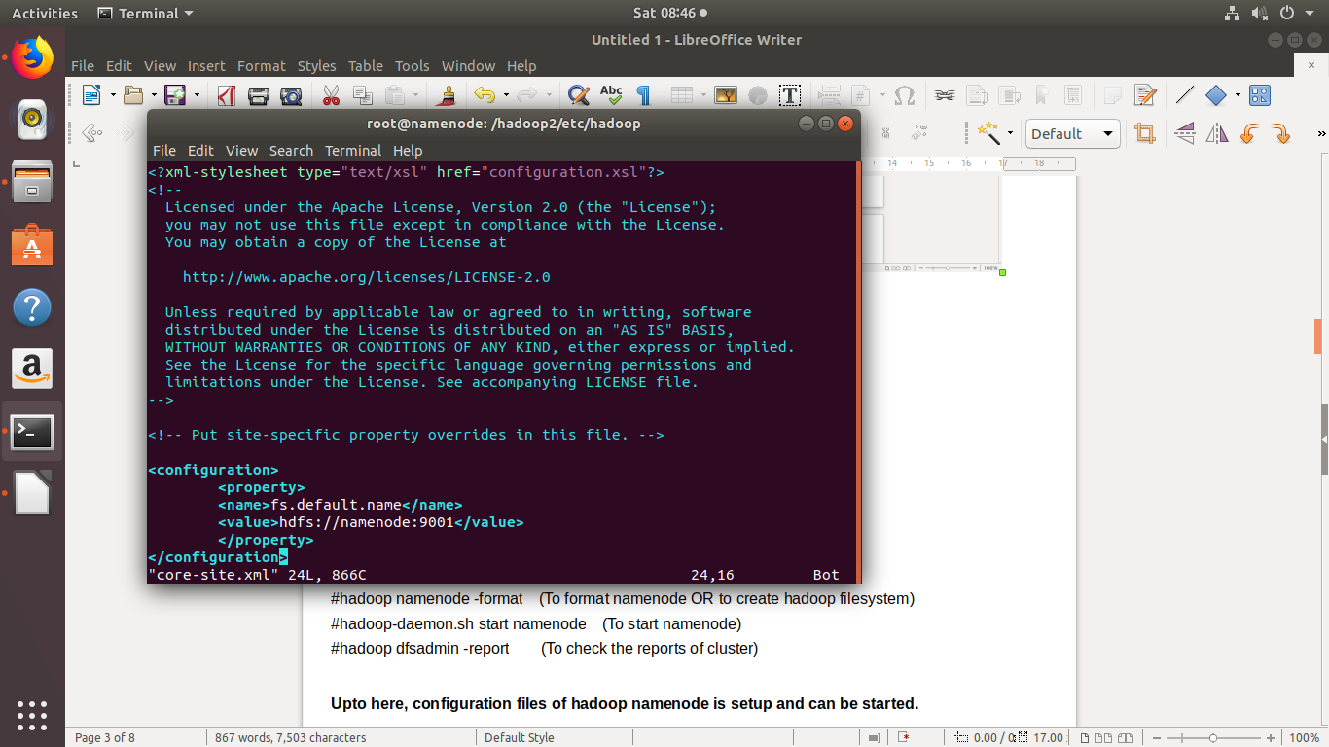
Now to start hadoop namenode using below command:

#hadoop namenode -format (To format namenode OR to create hadoop filesystem)
#hadoop-daemon.sh start namenode (To start namenode)
#hadoop dfsadmin -report (To check the reports of cluster)

Upto here, configuration files of hadoop namenode is setup and can be started.

Setting Up datanode (Apply these changes in datanode):

Open file hdfs-site.xml and make below changes in it’s configuration block.
#vim hdfs-site.xml
1. To give path of datanode directory:
<configuration>
<property>
<name>dfs.datanode.data.dir</name>
<value>/datanode</value>
</property>
</configuration>
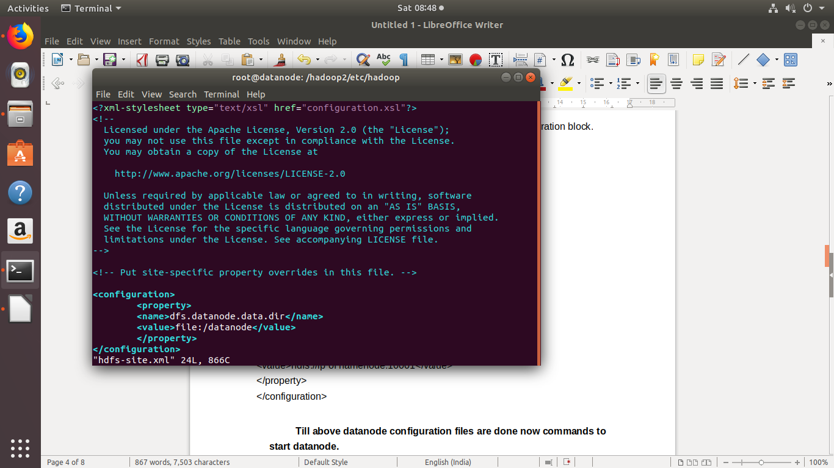

Now change in core-site.xml
2. To give namenode address to datanode
<configuration>
<property>
<name>fs.default.name</name>
<value>hdfs://ip of namenode:10001</value>
</property>
</configuration>
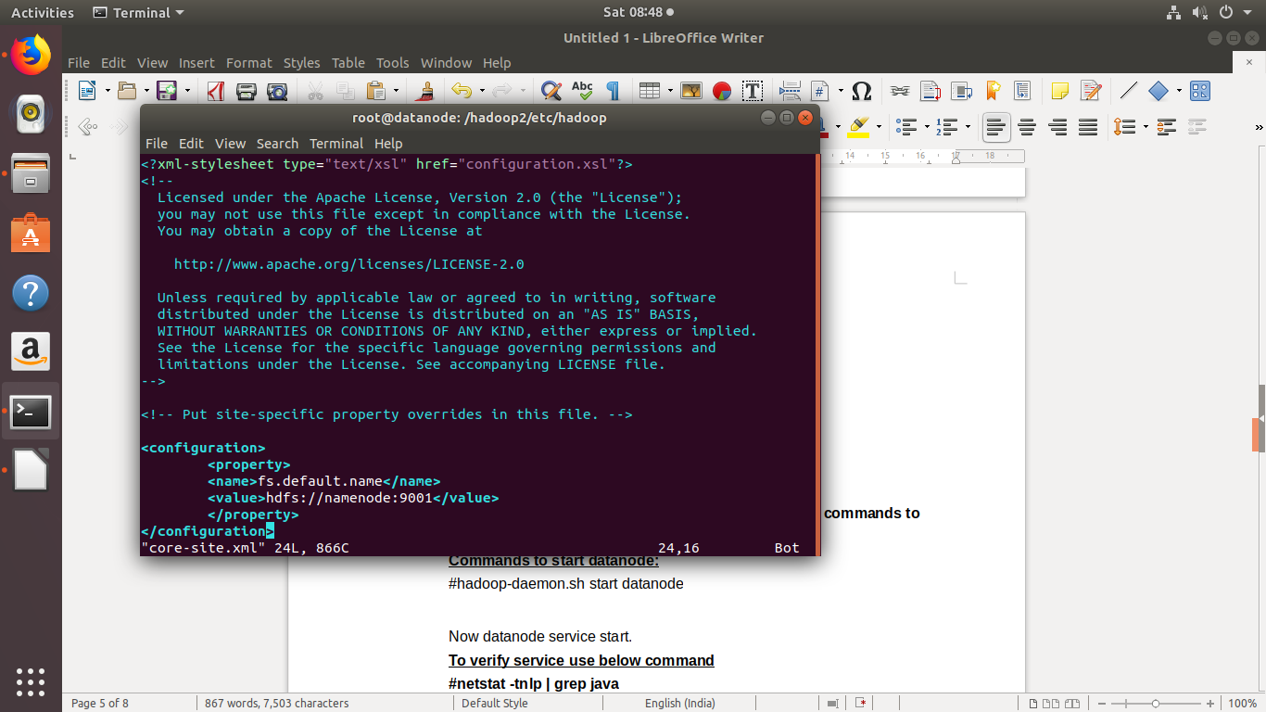
Till above datanode configuration files are done now commands to start datanode.
Commands to start datanode:
#hadoop-daemon.sh start datanode

Now datanode service start.
To verify service use below command
#netstat -tnlp | grep java
Above command will give the status of hadoop running ports.

Setting Up Yarn:
To setup yarn we need to make configuration in yarn-site.xml
At Resource Manager side:
#vim yarn-site.xml
<configuration>
<property>
<name>yarn.resourcemanager.resource-tracker.address</name>
<value>resourcemanager_ip:8031</value> //Tell the ip_address of resource tracker
</property>

<property>
<name>yarn.resourcemanager.scheduler.address</name>
<value>resourcemanager_ip:8030</value> //Tell the ip_address of scheduler
</property>
</configuration>
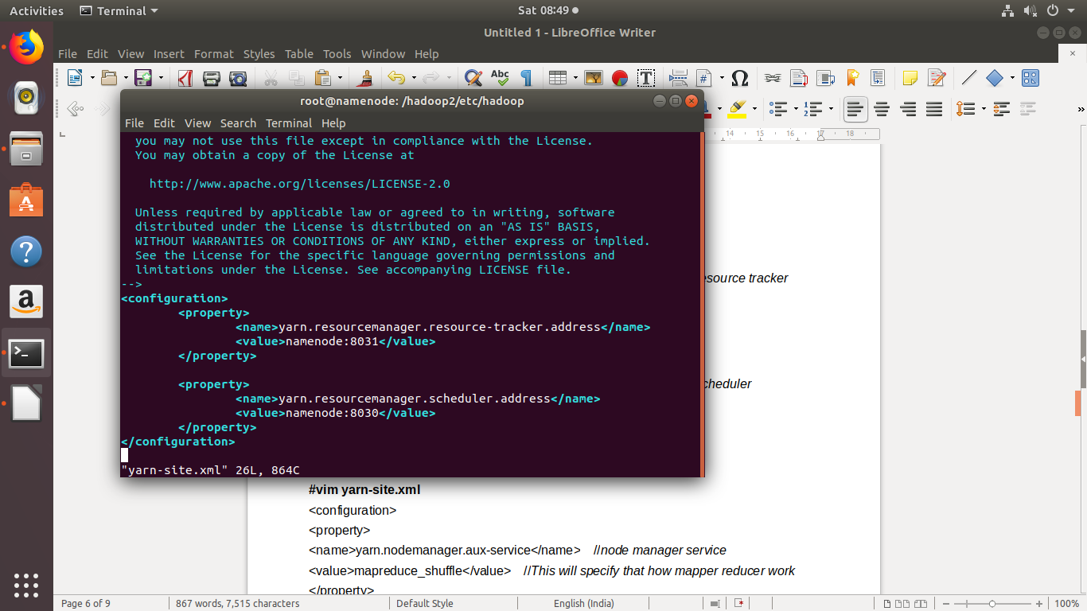
At Node Manager side:
#vim yarn-site.xml
<configuration>
<property>
<name>yarn.nodemanager.aux-service</name> //node manager service
<value>mapreduce_shuffle</value> //This will specify that how mapper reducer work
</property>

<property>
<name>yarn.resourcemanager.resource-tracker.address</name>
<value>resourcemanager_id:8025</value> //Tell the ip_address of resource tracker
</property>
</configuration>
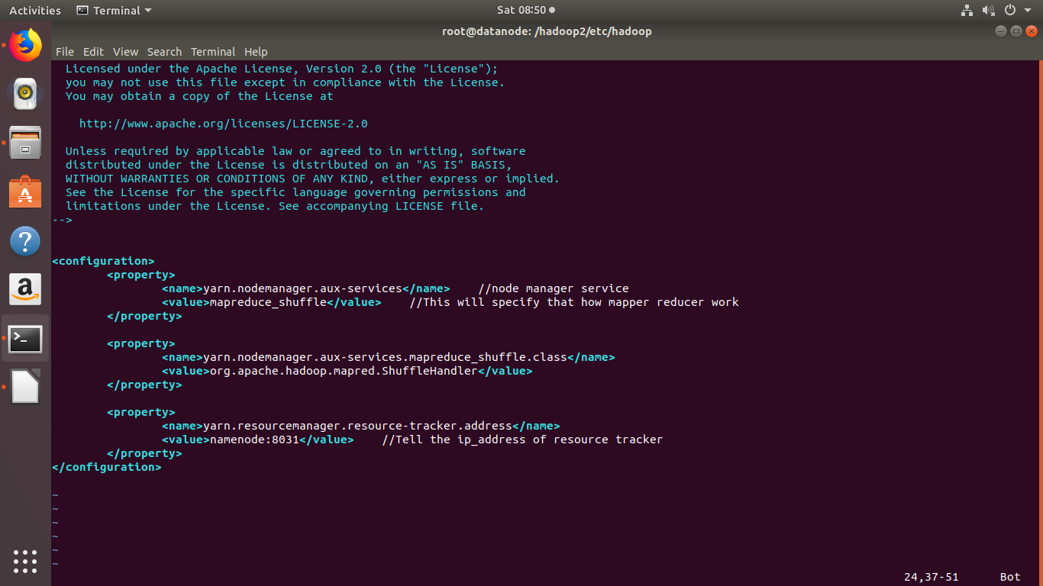
Command to start Resourcemanager( At namenode ):
Yarn-daemon.sh start resourcemanager

Command to start Nodemanager ( At datanode ):
Yarn-daemon.sh satrt nodemanager

Till Here hdfs and yarn is setup and can be run successfully.

